**Activity 6:** Tip Calculator & Challenge

Ryan Scott

Grand Canyon University  
Mobile Game Development

Prof. Shad Sluiter

**Tip Calculator Screenshot:**

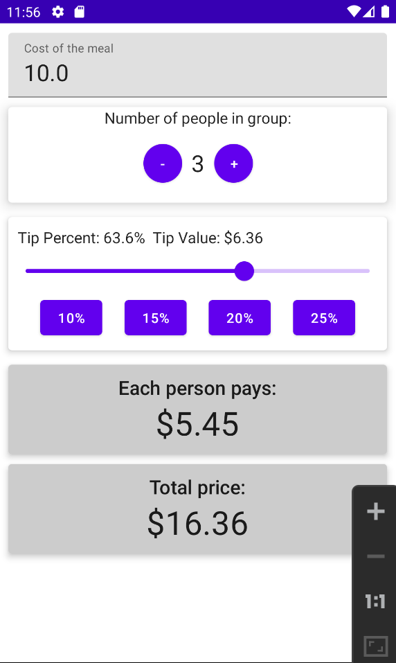

**Date to Date Challenge Screenshots:**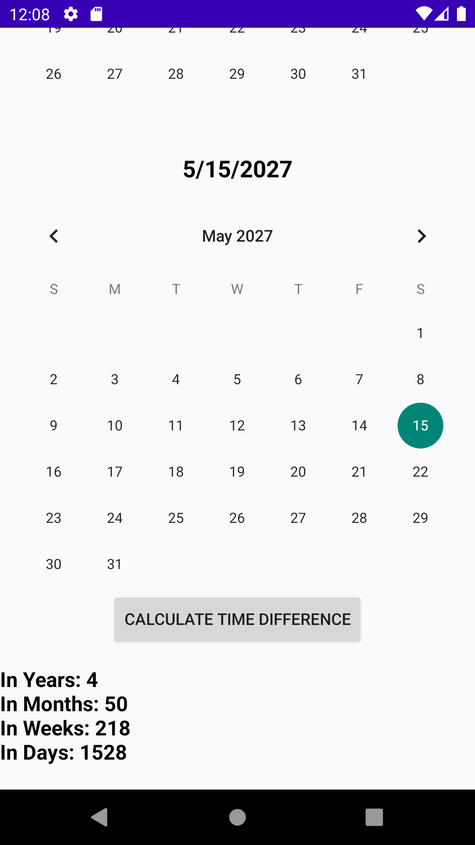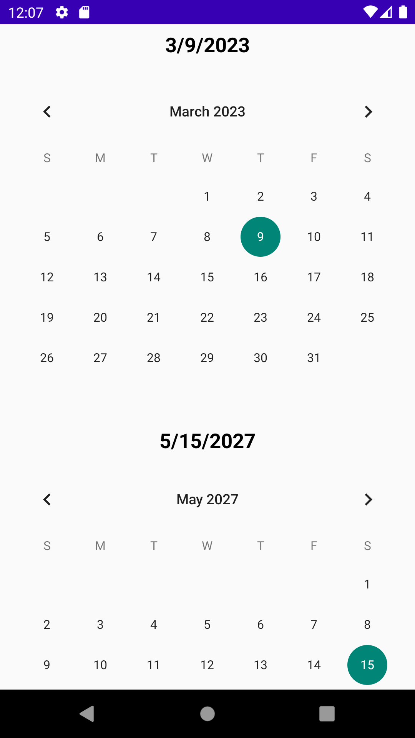

# What I learned

This activity taught me how to style a user interface with cards, how to use a slider control, how to create a custom control, how to use a ViewModel to manage a more complex set of interrelated values, and how to modify XML with Calendar objects. Android development requires a range of skills that can be useful for developing complex and feature-rich applications. By mastering these skills, I can become a more effective Android developer and build applications that meet my users' needs more effectively.